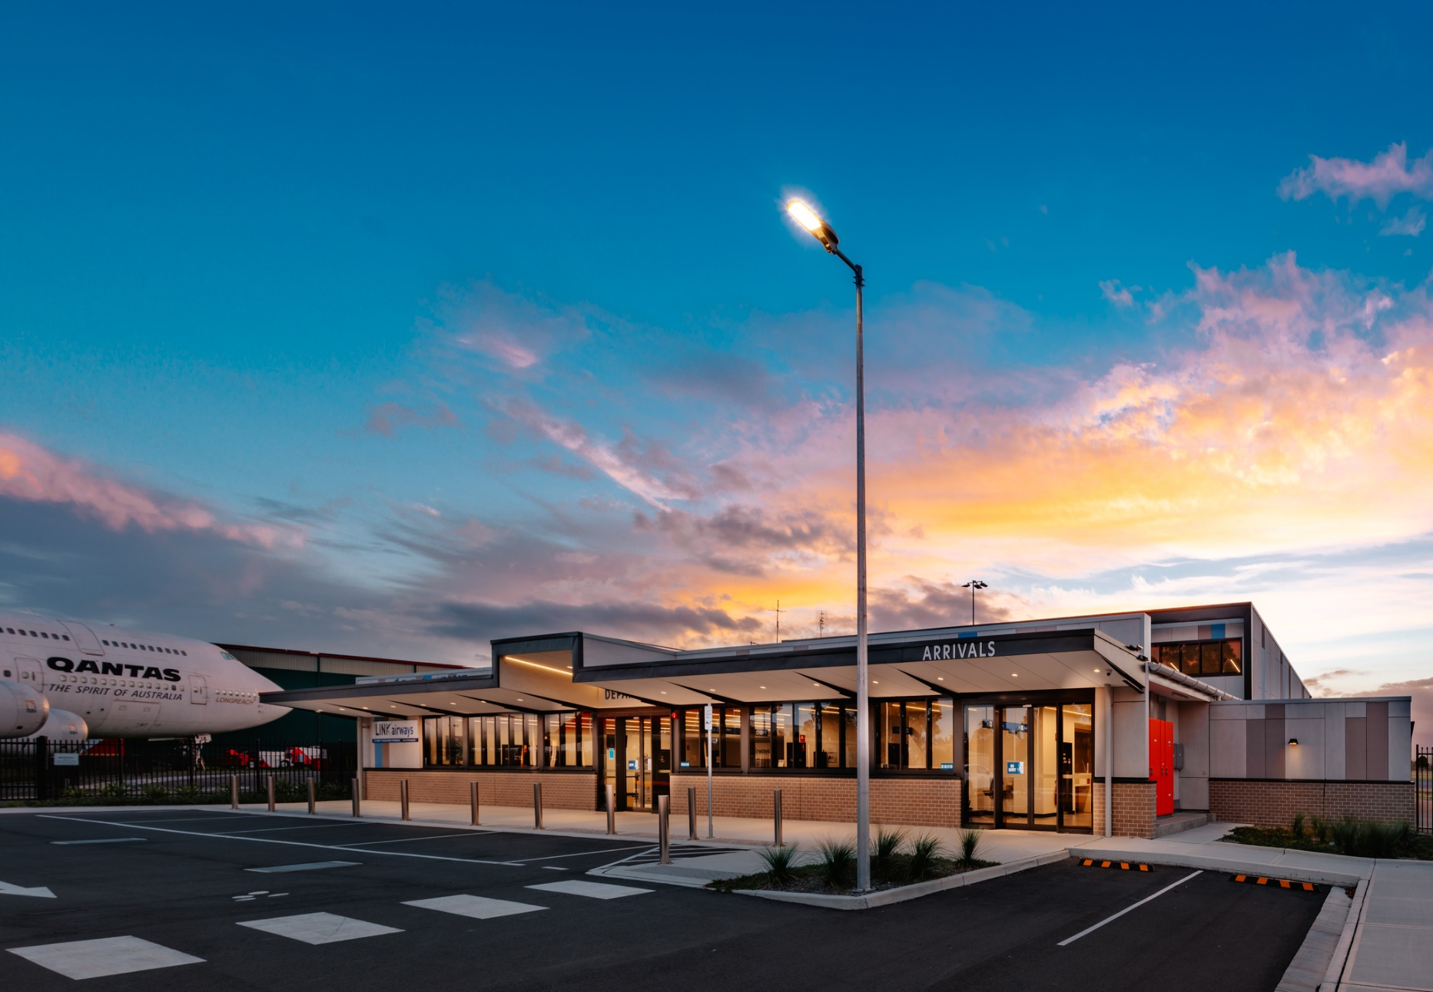

METHOD OF
WORKS PLAN

Shellharbour Airport
MOWP Number: YSHL2024- 01
Project Description: Fuel Farm Apron Upgrade
Authored by: Breanna Parkes

Contents
1. Works Information 3
1.1 Scope of works 3
1.2 Set out of works 3
1.3 Restrictions to Aircraft Operations 3
2. Emergency and Adverse Weather 4
2.2 Emergency Assembly Point Map 4
2.3 Restrictions on persons conducting work at Shellharbour Airport 5
3. NOTAMS 6
4. Personnel and Equipment 7
6. Administration 8
7. Authority 9
7.2 MOWP Expiry Date 9
7.3 Approval 9
8. Drawings 10
9. Distribution List 11

1. Works Information

Scope of works
- Stage 1
Place U/S Cones on TWY C, excavate marked up area to 50mm and profile grade – Milling materials will be transported on site with escort to stockpile near Toll via TWY E
- Stage 2
Lay asphalt and roll out
- Stage 3
Reinstate line marking and open site as operational
MOWP STAGE | WORKING DAYS | WORKING HOURS (LOCAL)
1
2
3
*All stages to be completed within 24hrs

Set out of works
If NOTAM is applicable the actual date and time of commencement will be advised on NOTAM, to be issued not less than 48hr before work commences.

1.3 Restrictions to Aircraft Operations
MOWP STAGE | AIRCRAFT RESTRICTIONS | START  (LOCAL) | FINISH  (LOCAL)
1 | TWY C not available  Fuel Bowsers not available | 0600 | 1700
2 | TWY C not available  Fuel Bowsers not available | 0600 | 1700
3 | TWY C not available  Fuel Bowsers not available | 0600 | 1700

2. Emergency and Adverse Weather
In the event of an emergency all personnel will follow instructions from the Airports nominated Works Safety Officer. All persons conducting works will have been briefed on Emergency Assembly Point prior to works and completed Site Induction Materials

2.2 Emergency Assembly Point Map
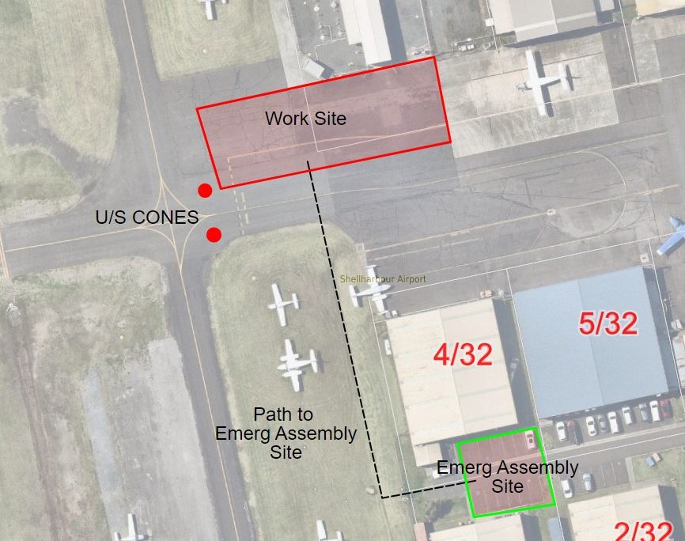

2.3 Restrictions on persons conducting work at Shellharbour Airport
Works is to take place on and in the vicinity of aircraft movement areas, the specific requirements of the MOWP together with instructions from the WSO shall be strictly followed at all times by all Contractors, Sub-Contractors and other workers.
While at the work site, all vehicles, plant and personnel shall remain within the limits of the works area designated by the WSO. All vehicles and plant not actually engaged in the works shall be parked clear of the works and movement areas in an area designated by the WSO or Site Supervisor.
All plant and equipment transiting on airside is to operate under the instruction of the WSO’s via: UHF channel 45
The Contractor is to take every precaution to prevent any spillage/FOD of material on or in the vicinity of aircraft movement areas, or in transit to and from the work site. Any spillage/FOD which does occur is to be immediately removed by the Contractor to the satisfaction of the WSO.
The Contractor is to prevent material from being blown onto aircraft movement areas by watering or other appropriate control measures. Spoil is to not to be left for prolonged periods; at a minimum secured in skips, trucks or removed after each day’s work.
On completion of each work period and on each occasion the movement area is returned to active use* if NOTAM is in place. The Works Supervisor is to ensure the works area is made serviceable, including the removal of all FOD hazards, to the satisfaction of the WSO. The WSO is to advise via CTAF 127.3 works are completed. Height restrictions on machinery will be established and NOTAMS/ approvals will be sought if infringing on OLS.

3. NOTAMS
The nominated Works Safety Officer will be responsible for publishing NOTAMS for each stage of the works.
NOTAMS are to be published at least 48 hours prior to the commencement of the works. A full list of the NOTAMS with the relevant stages as listed below:
Stage | NOTAM text (UTC)
1 | A) EAST APRON OF TWY C NOT AVLB DUE MOWP YSHL2024-01  B) JET A1 & AVGAS BOWSERS NOT AVLB DUE MOWP YSHL2024-01  TRUCK SERVICE AVLB BY ARRANGEMENT BETWEEN HRS (LOCAL) 0900-1700 PH VIVA FUEL 0437 323 185
2 | A) EAST APRON OF TWY C NOT AVLB DUE MOWP YSHL2024-01  B) JET A1 & AVGAS BOWSERS NOT AVLB DUE MOWP YSHL2024-01  TRUCK SERVICE AVLB BY ARRANGEMENT BETWEEN HRS (LOCAL) 0900-1700 PH VIVA FUEL 0437 323 185
3 | A) EAST APRON OF TWY C NOT AVLB DUE MOWP YSHL2024-01  B) JET A1 & AVGAS BOWSERS NOT AVLB DUE MOWP YSHL2024-01  TRUCK SERVICE AVLB BY ARRANGEMENT BETWEEN HRS (LOCAL) 0900-1700 PH VIVA FUEL 0437 323 185

4. Personnel and Equipment
All personnel associated with the works shall be bound by any instructions issued by the WSO, this may include refused access to site or operations.
Vehicles will be required to display a warning beacon that provides 360 degrees of visibility and turned on at all times when airside.
It is up to the contractor to follow their own internal SWMS, WHS and PPE requirements when conducting works on the Aerodrome. A copy of SWMS must be provided to the WSO prior to work commencing and a record will be kept.
At the end of each working day, all plant and equipment is to be clear of aircraft maneuvering areas and to be stored within the designated work areas to the satisfaction of the WSO.
Any damage to the aerodrome are to be reported immediately to the WSO. Any damage sustained is to be rectified by the contractor.

6. Administration
Project Manager
Airport Manager – Paul Ferguson
Contractor Supervisor
Roadworx – Colin Hannify
Works Safety Officer
Airport Compliance Coordinator – Breanna Parkes
6.4 Contact List
Title | Name | Contact Details
Works Safety Officer | Breanna Parkes | 0421 044 135
Airport Manager | Paul Ferguson | 0417 625 595
Aerodrome Reporting Officer (24 hour) | Michael Biris | 0421 044 153
Project Officer | Airport Management | As above
Contractor Supervisor | Roadworx – Colin Hanniffy | 0408 206 805
Contractors | Roadworx – Adam Williamson | 0488 102 086

7. Authority

7.2 MOWP Expiry Date
This MOWP will remain active until 29/2/24 unless extended with revision or authorised by the Airport Manager

7.3 Approval
Under the authority of the following signatures, this MOWP is approved for release.
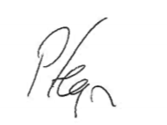
Paul Ferguson
Airport Manager

8. Drawings

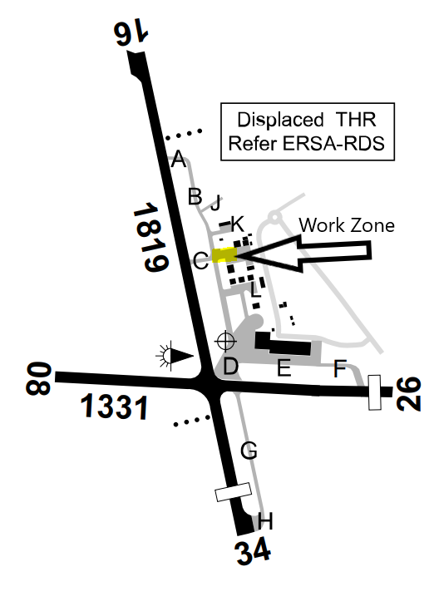

Name | Organisation | Email Address
Slavica Despotovic | CASA | Slavica.Despotovic@casa.gov.au
Jenny Adams | SCC | Jenny.adams@shellharbour.nsw.gov.au;
Breanna Parkes | SCC | breanna.parkes@shellharbour.nsw.gov.au;
Ryan Roche | Skydive the Beach | aircraftadmin@skydive.com.au;  gmaircraft@skydive.com.au  flightops@skydive.com.au
Bob De La Hunty | HARS | delahunty@bigpond.com;
John Cleary  Phil Ayrton | The Illawarra Flyers | johncl3ary@gmail.com;  Phil Ayrton <phil.ayrton999@gmail.com>
Ned McIntosh | Sydney Microlight Centre | criticalmass@hotkey.net.au;
Touchdown | Touchdown Helicopters | info@touchdownhelicopters.com.au;
Bill Quintal | NSW Air Flight Training Pty Ltd | pilots@nswair.com.au
Andrew Agnew | Gyrocopters | andy@aerospacia.com;
Joanna Murphy | Valhalla Helicopters | joannamurphy@hotmail.com;
Wayne Perry | Viva Refuelling | wayne@wollongongaviationfuels.com.au;
Chris Clark | Five Point Aviation | contact@fivepointaviation.com.au;
Gavin P | Total Aerospace Solutions | gavinp@totalaerospacesolutions.com;
Bruce Robbins | Flight Training | bruce.robbins@westnet.com.au;
Dave Smith | Air Safety Solutions | info@airsafetysolutions.com.au;
Nathan Haythorpe | Toll Helicopters | nathan.haythorpe@tollgroup.com;
Jason Minns – Safety Officer |  | jason.minns@tollgroup.com;
Jeff Boyd | Fly Corporate | jboyd@corporate-air.com.au;

9. Distribution List

